A000-Afr-Benin miniature iron Fon shield

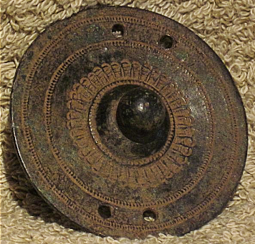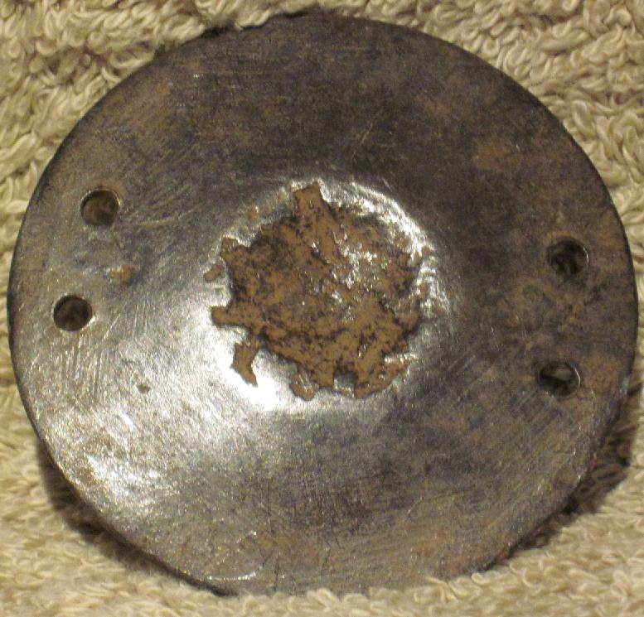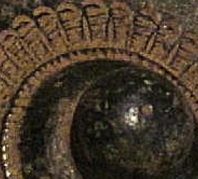

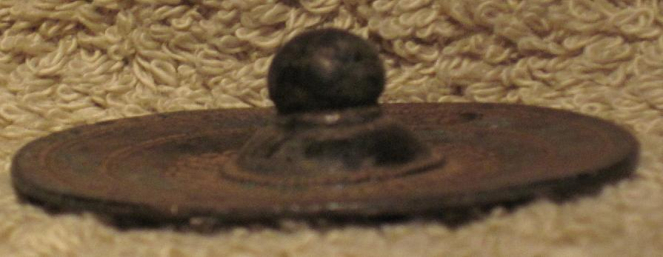

Figs. 1-4. Benin miniature iron Fon shield used as an apotropaic amulet. Various views.

Formal Label: Benin, miniature iron Fon shield used as an apotropaic amulet

Accession Number:

LC Classification: N7397

Date or Time Horizon: 19th century

Geographical Area: Benin

Cultural Affiliation: Fon

**Map:** showing Fon and the four Gbe language groups.

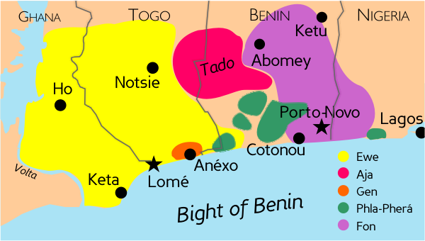

Fig. 5. From: [Mark Dingemanse](https://en.wikipedia.org/wiki/User:Mark_Dingemanse), https://upload.wikimedia.org/wikipedia/commons/0/03/Gbe_languages.png

Medium: Bronze

Dimensions: 2.25 in. diaWeight:

Provenance: Fon Royal regalia

**Condition: Partially rusted**

**Discussion:**

The **Fon** people (also **Fon nu**, **Agadja** andr **Dahomey**) are a major West African ethno-linguistic group, whose language is part of the Niger-Congo group. The Fon have been concentrated in Benin and southwestern Nigeria since the seventeenth century. In Benin, Fon shields were used not only as defensive weapons but also as spiritual objects made of wood, hides and iron as in this case. Fon religion (*Vodoun*, *Vodzu*, *Vodu, Vodun*) which is encompasses ancestral spirits and public and private deities and amulets or charms of which the present specimen is an example. The geometric designs that surround the central boss are symbolic of a cobra’s raised head and hood, which is designed to enhance the protective symbolism of the shield.



Fig. 6. Cobra hoods surrounding the central boss.

Metal required not only the expert knowledge of a metalsmith (in this case an iron monger) but also the use of a smelter and bellows to manufacture the fiery product. Because of the use of fire, the product was considered sacred. This iron disk would have been affixed to royal regalia as an apotropaic appurtenance designed to emulate a shield in order to protect the wearer in daily activities. Full-sized Fon shields would have had a diameter of about a foot.

**References:**

Capo, Hounkpati B.C. 1988. *Renaissance du Gbe: Réflexions critiques et constructives sur L'EVE, le FON, le GEN, l'AJA, le GUN..* Hamburg: Helmut Buske Verlag.

Capo, Hounkpati B.C. 1991. *A Comparative Phonology of Gbe*, Publications in African Languages and Linguistics, 14. Berlin/New York: Foris Publications & Garome, Bénin: Labo Gbe LLC.